EXPERIMENT NO. 08
AIM
Deploy the application using Docker and GitHub.

LEARNING OUTCOMES
Deploy full-stack application on cloud platform and present capstone.

THEORY

Fundamentals of Containerization & Docker
- Containerization: A lightweight OS-level virtualization method that packages application source code together with its runtime dependencies, libraries, system tools, and configuration files into an isolated execution unit called a container.

Containers vs. Virtual Machines (VMs):
  - Virtual Machines abstract hardware, requiring a full guest operating system on top of a hypervisor, which consumes significant memory, storage, and boot time.
  - Docker Containers share the host system’s OS kernel, isolating process spaces and filesystems. This makes containers lightweight (megabytes vs. gigabytes), fast to start (milliseconds vs. minutes), and resource efficient.

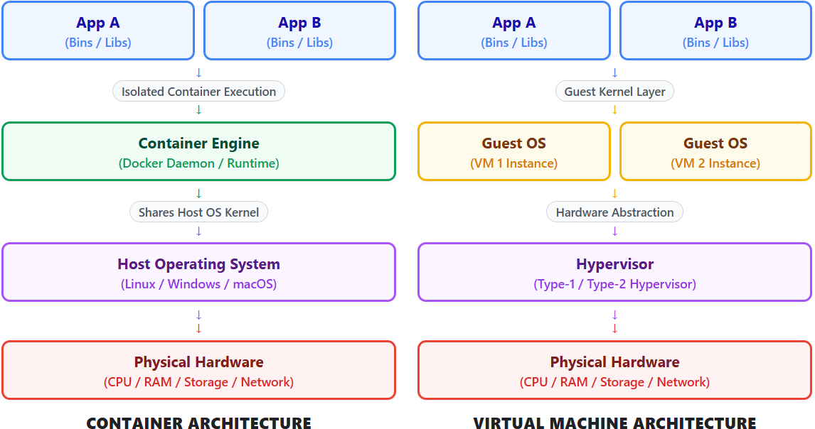

Core Docker Artifacts:
  - Dockerfile: A declarative text blueprint containing step-by-step instructions to assemble a Docker image.
  - Docker Image: An immutable, read-only template built in stacked filesystem layers.
  - Docker Container: A runnable, stateful instance of a Docker image operating in an isolated user space.

Multi-Stage Docker Builds
- A Docker feature that uses multiple FROM statements in a single Dockerfile. Each FROM instruction begins a new build stage using a distinct base image.
- Separation of Build-time vs. Runtime Environments:
  - Build Stage: Utilizes heavyweight SDK base images containing compilers, build tools, and package managers (e.g., maven:3.9 or node:18) to compile source code into execution binaries (.jar or optimized React bundle).

  - Runtime Stage: Copies only the final compiled artifacts into a clean, minimal runtime image (e.g., eclipse-temurin:17-jre-alpine or nginx:alpine).

Multi-Container Orchestration with Docker Compose
- A tool for defining and running multi-container Docker applications through a single declarative YAML configuration file (docker-compose.yml).

Isolated Virtual Networking:
  - Docker Compose automatically initializes an isolated bridge network (fullstack-net).
  - Service DNS Name Resolution: Containers attached to the same custom bridge network resolve other containers using their defined service names (e.g., mysqldb or backend) as domain aliases rather than ephemeral container IP addresses

Container Lifecycle & Dependency Management:
  - depends_on: Defines the start and stop order of dependent services.
  - healthcheck: Executes status commands inside a container (e.g., mysqladmin ping) to verify that an internal service engine (like MySQL) is fully ready to accept socket connections before downstream containers (like Spring Boot) launch.

Data Persistence via Docker Volumes:
  - Containers are ephemeral by default; data written inside a container is lost when it stops.
  - Named Volumes: Managed persistent storage spaces created on the host file system and mounted into specific container paths (e.g., /var/lib/mysql), ensuring database records persist across container rebuilds or host reboots.

CI/CD Workflows with GitHub Actions
- Continuous Integration (CI): The practice of automatically triggering build, syntax-check, and automated test pipelines every time code changes are committed and pushed to a central repository (e.g., GitHub).
- Continuous Delivery (CD): Automatically preparing, packaging, and staging verified build artifacts (such as Docker images) into container registries (e.g., Docker Hub, GitHub Packages) for deployment to production environments.

- GitHub Actions Workflow Architecture:
  - Events (on): Triggers that launch workflows, such as push or pull_request to the main branch.
  - Jobs: A set of sequential steps executing on a isolated virtual machine runner (e.g., ubuntu-latest).
  - Steps & Actions: Tasks executing specific shell commands (docker build) or reusing pre-built community actions (e.g., actions/checkout or docker/setup-buildx-action).

OUTPUT

CONCLUSION
………...……………………………………………………………………………………….
…………………………………………………………………………………………………
…………………………………………………………………………………………………

PRACTICAL RELATED QUESTIONS
- What is the primary benefit of using multi-stage builds in Dockerfiles for React and Spring Boot applications?
- How does Docker Compose enable communication between frontend, backend, and database containers without hardcoding IP addresses?
- Why is depends_on alone insufficient for controlling startup order between MySQL and Spring Boot, and how does healthcheck fix this?

………...……………………………………………………………………………………….
…………………………………………………………………………………………………
…………………………………………………………………………………………………
…………………………………………………………………………………………………
………...……………………………………………………………………………………….
…………………………………………………………………………………………………
………...……………………………………………………………………………………….
…………………………………………………………………………………………………
…………………………………………………………………………………………………
…………………………………………………………………………………………………
………...……………………………………………………………………………………….
…………………………………………………………………………………………………
………...……………………………………………………………………………………….
…………………………………………………………………………………………………
…………………………………………………………………………………………………
…………………………………………………………………………………………………
………...……………………………………………………………………………………….
…………………………………………………………………………………………………

………...……………………………………………………………………………………….
…………………………………………………………………………………………………
………...……………………………………………………………………………………….
…………………………………………………………………………………………………
………...……………………………………………………………………………………….
…………………………………………………………………………………………………
…………………………………………………………………………………………………
…………………………………………………………………………………………………
…………………………………………………………………………………………………
…………………………………………………………………………………………………
…………………………………………………………………………………………………
………...……………………………………………………………………………………….
…………………………………………………………………………………………………
…………………………………………………………………………………………………
…………………………………………………………………………………………………
…………………………………………………………………………………………………
…………………………………………………………………………………………………
…………………………………………………………………………………………………
………...……………………………………………………………………………………….
…………………………………………………………………………………………………
…………………………………………………………………………………………………
…………………………………………………………………………………………………
…………………………………………………………………………………………………
…………………………………………………………………………………………………
…………………………………………………………………………………………………
…………………………………………………………………………………………………
…………………………………………………………………………………………………
…………………………………………………………………………………………………
…………………………………………………………………………………………………

…………………………………………………………………………………………………
…………………………………………………………………………………………………
…………………………………………………………………………………………………
…………………………………………………………………………………………………
…………………………………………………………………………………………………
…………………………………………………………………………………………………
…………………………………………………………………………………………………
…………………………………………………………………………………………………
…………………………………………………………………………………………………
…………………………………………………………………………………………………
…………………………………………………………………………………………………
…………………………………………………………………………………………………
…………………………………………………………………………………………………
…………………………………………………………………………………………………
…………………………………………………………………………………………………

ASSESSMENT SCHEME

Performance Indicator | Max. Marks | Marks Obtained
Understanding | 5
Implementation | 7
Timely Submission | 3
Total | 15

Signature of Faculty with Date

